**DAILY ONLINE ACTIVITIES SUMMARY**

|  |  |  |  |  |  |  |  |
| --- | --- | --- | --- | --- | --- | --- | --- |
| **Date:** | **07 June 2020** | | | | **Name:** | **KHATHEEJA SAFREENA** | |
| **Sem & Sec** | **4th sem, 2nd year** | | | | **USN:** | **4AL18CS037** | |
| **Online Test Summary** | | | | | | | |
| **Subject** | | **------------------** | | | | | |
| **Max. Marks** | | **----** | | **Score** | | **-----** | |
| **Certification Course Summary** | | | | | | | |
| **Course** | **MARKETING FOUNDATION.** | | | | | | |
| **Certificate Provider** | | | **Great Learning** | **Duration** | | | **5hrs** |
| **Coding Challenges** | | | | | | | |
| **Problem Statement:1 program** | | | | | | | |
| **Status: Executed** | | | | | | | |
| **Uploaded the report in Github** | | | | **Yes** | | | |
| **If yes Repository name** | | | | **[http://shafreenasharief / lockdown-coding](http://shafreenasharief / lockdown-coding" \o "http://shafreenasharief / lockdown-coding)**  **[http://shafreenasharief / locked-down--certification-course](http://shafreenasharief / locked-down--certification-course" \o "http://shafreenasharief / locked-down--certification-course)**  **[http://shafreenasharief / Daily\_Report](http://shafreenasharief / Daily_Report" \o "http://shafreenasharief / Daily_Report)** | | | |
| **Uploaded the report in slack** | | | | **Yes** | | | |

Certification Course Details: (Attach the snapshot and briefly write the report for the same)

Coding Challenges Details: (Attach the snapshot and briefly write the report for the same)

**CERTIFICATION COURSE SUMMARY:**

Today I started certificate course on '**MARKETING FOUNDATION**', through GREAT LEARNING.The course was scheduled for 5 hrs .I completed 2 modules that are Marketing strategy, Product Life cycle.I attempted quiz ,which gave me a clear veiw about the topics that were thought and discussed.It consists of 10 modules which also include assessments.

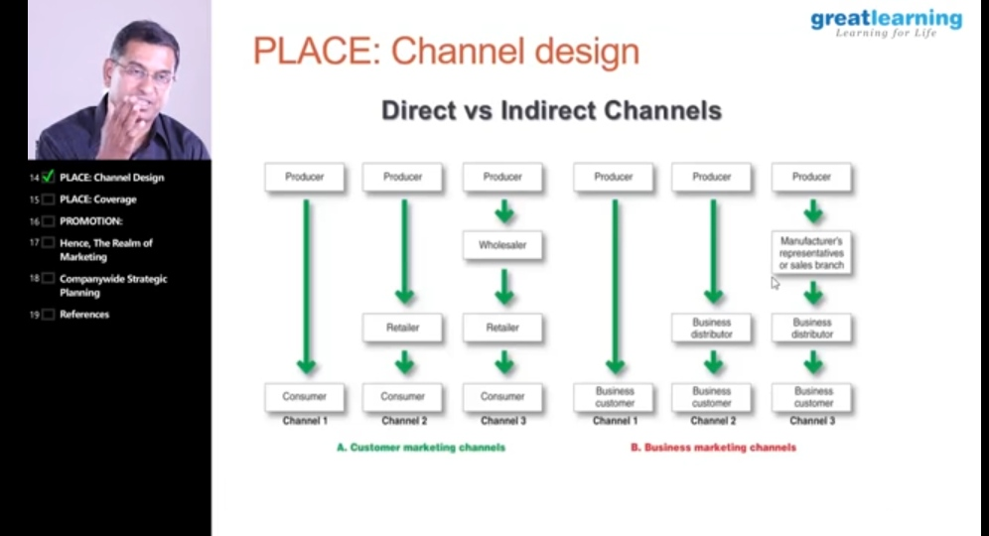

**CODING CHALLENGES:**

Today I solved 1 coding challenge,

1. **Write a C++ Program to swap two numbers using friend as a bridge concept.**

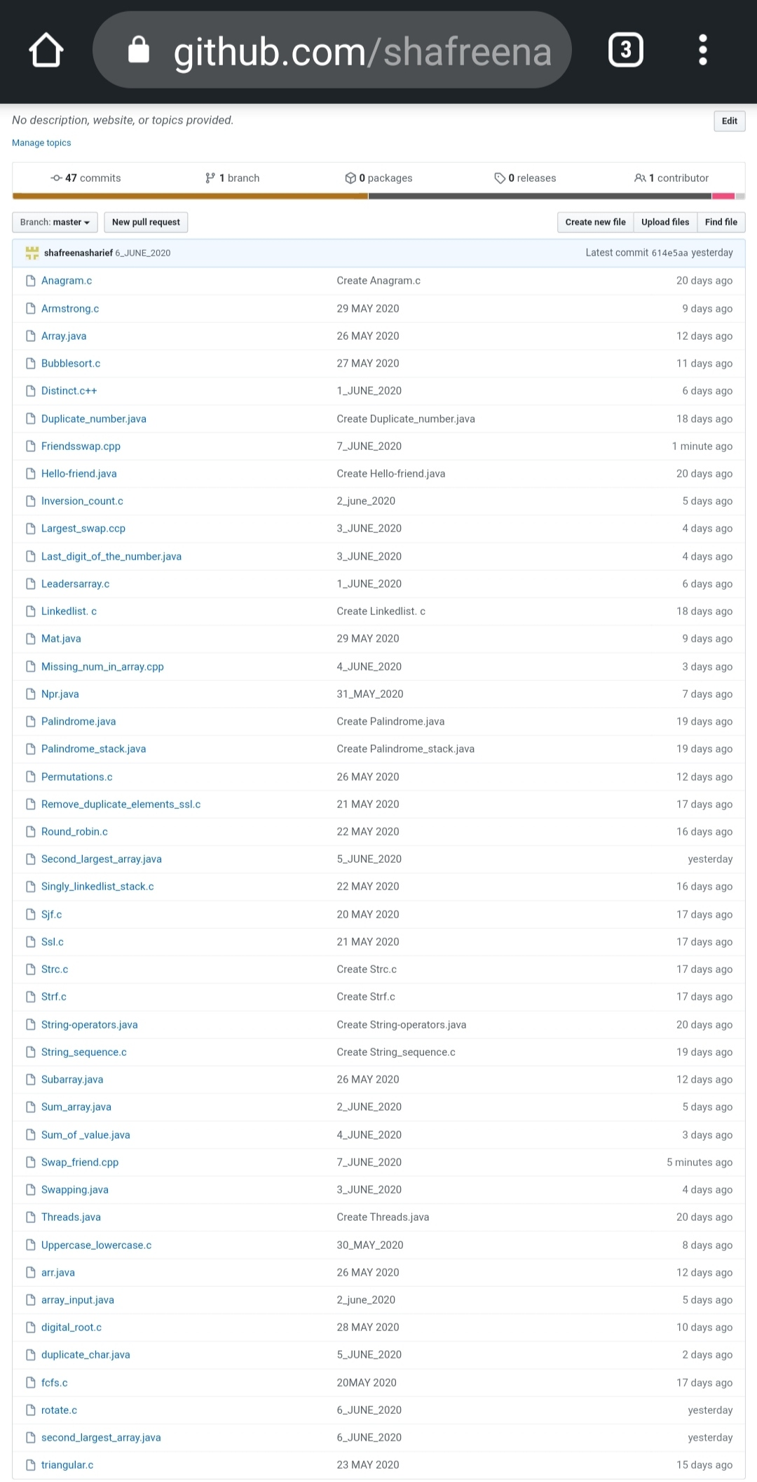

SOLUTION : I have uploaded the solution of the above 1 coding problems in my GitHub repository.

http://shafreenasharief / lockdown-coding

http://shafreenasharief / locked-down--certification-course

http://shafreenasharief / Daily\_Report